JAVA
Run:-
javac filename.java
java filename
Java Syntax:-
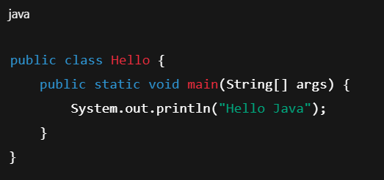

🔍 Java Syntax Breakdown
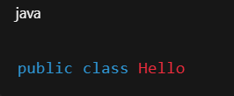
1️⃣ Class Declaration

Work:
- Program class se start hota hai
- Class name = File name same hona chahiye
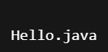
File name:

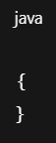
2️⃣ Curly Braces { }
Work:
- Code block define karta hai
- Class block
- Method block
Java me har block { } me hota hai.
3️⃣ Main Method Syntax
Work:
Ye Java ka entry point hai.
Program execution yahi se start hota hai.
Word | Meaning
public | Sab access kar sakte
static | Object banane ki need nahi
void | Return value nahi
main | Method name
String[] args | Command line arguments
Breakdown:

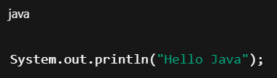
4️⃣ Statement

Work:
Output print karta hai.
5️⃣ Semicolon ;
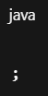
Work:
Statement end karta hai.
Semicolon missing → Error ❌

Comment
- What is Comment
📖 Comment kya hota hai?
Comment = Code ke andar likha hua explanation
Jo program run hote time execute nahi hota.
👉 Use hota hai:
- Code samjhane ke liye
- Notes likhne ke liye
- Debugging ke liye
- Code temporarily disable karne ke liye
🧾 Types of Comments in Java
Java me 3 types ke comments hote hain:
- Single Line Comment
- Multi Line Comment
- Documentation Comment

1️⃣ Single Line Comment:-
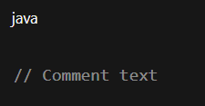
Syntax:

Example:

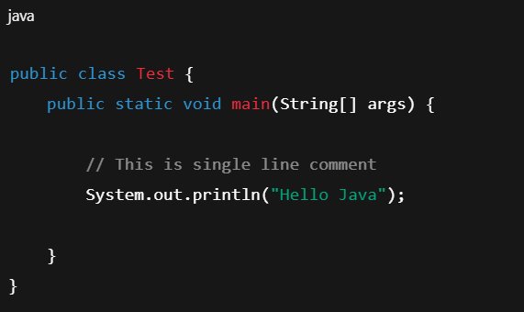

📌 // ke baad jo likhoge → run nahi hoga.

2️⃣ Multi Line Comment
Jab bada explanation likhna ho.
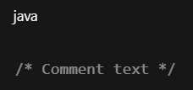
Syntax:

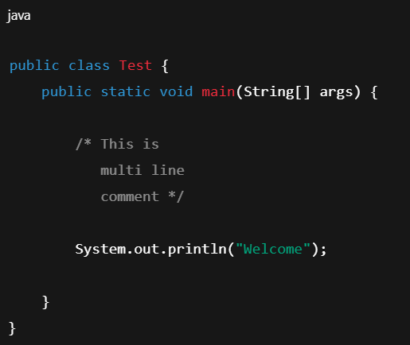
Example:

📌 /* se start → */ par end.

3️⃣ Documentation Comment (JavaDoc)
Professional projects me use hota hai.
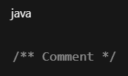
Syntax:

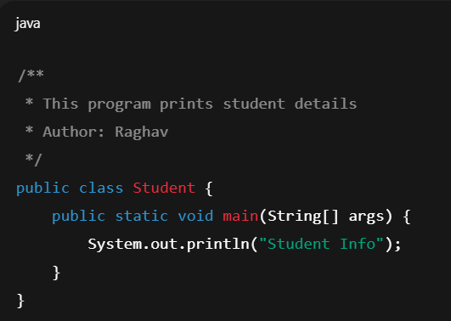
Example:

👉 Isse Java Documentation generate hoti hai.
Java Documentation
Documentation comment ek special comment hota hai jo:
- Code explain karta hai
- Aur Java tool usko read karke documentation file bana deta hai

⚙️Documentation Generate kaise kare?
Question:- 👇
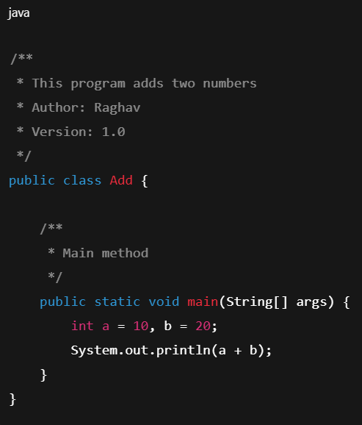
Step 1 — File save karo
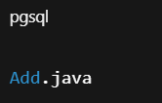

Step 2 — Command Prompt open karo
Step 3 — Command run karo
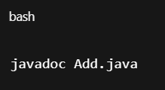

📂 Output kya milega?
Java automatically ye files bana dega:
index.html
Add.html
package-summary.html
etc.
👉 Ye sab Documentation Website jaisi hoti hain.
Browser me open karo → full code explanation dikhega.

🎯 Real Life Use
Documentation generate use hota hai:
- Software companies
- API documentation
- Library documentation
- Team projects
- GitHub projects
🔍 Difference
Comment Type | Use
//Hello | Simple note
/* hello  */ | Multi explanation
/**  *hello  */ | Documentation generate

Errors in Java
❌ How Many Types of Errors in Java?
Java me 3 types ke Errors hote hain:
1️⃣ Compile Time Error
2️⃣ Run Time Error
3️⃣ Logical Error
🧠 Easy Memory Trick
C R L
- C → Compile
- R → Runtime
- L → Logical
1️⃣ Compile Time Error
📖 Definition
Jo error program compile hote time aata hai.
Matlab:
javac Program.java run karte hi error aa jaye.
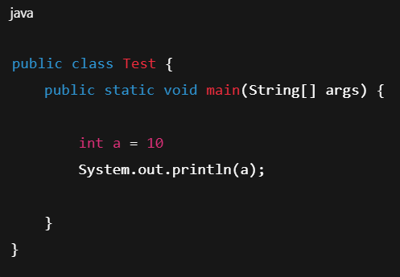
💻 Example:-
Error kyu?
Semicolon ; missing.
🔍 Compile Error Causes
- Semicolon missing
- Syntax wrong
- Variable not declared
📌 Output
Program run hi nahi hoga.

- Wrong keyword
- Braces missing
2️⃣ Run Time Error
📖 Definition
Program compile ho jata hai
But run karte time crash ho jata hai.

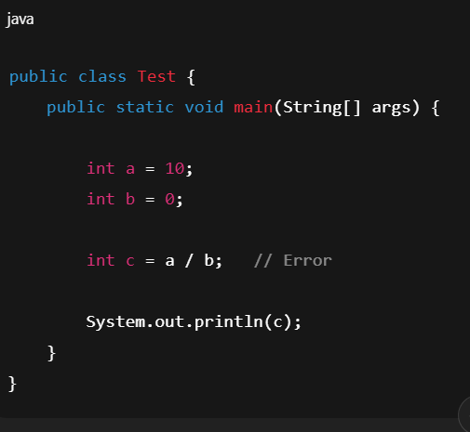
💻 Example:-

Error kya hai?
Number divide by zero ❌
🔍 Runtime Error Causes
- Divide by zero
- Array index out of bound
- Null pointer
- File not found
- Database connection fail

📌 Output
Program start hoga → beech me crash.

3️⃣ Logical Error
📖 Definition
Program run hota hai
But output galat aata hai.
Compiler error nahi deta.
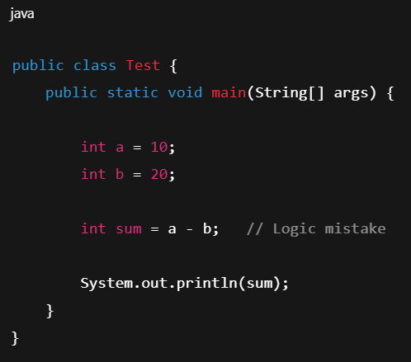
💻 Example:-

Error kya hai?
Addition karna tha
Minus kar diya.
Output:- -10
But expected:
30

🔍 Logical Error Causes
- Wrong formula
🎯 Real Life Example
Socho exam:
- Question galat likh diya → Compile error
- Exam hall me pen toot gaya → Runtime error
- Answer galat solve kiya → Logical error

- Wrong operator
- Wrong condition
- Algorithm mistake

